Code:

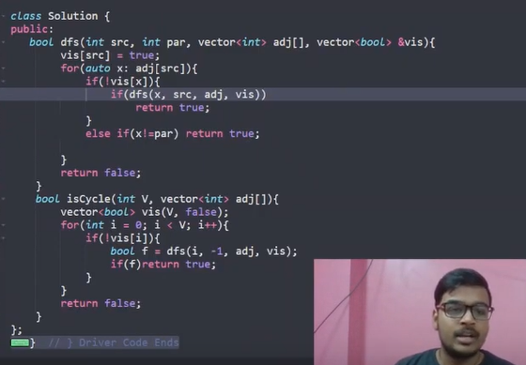

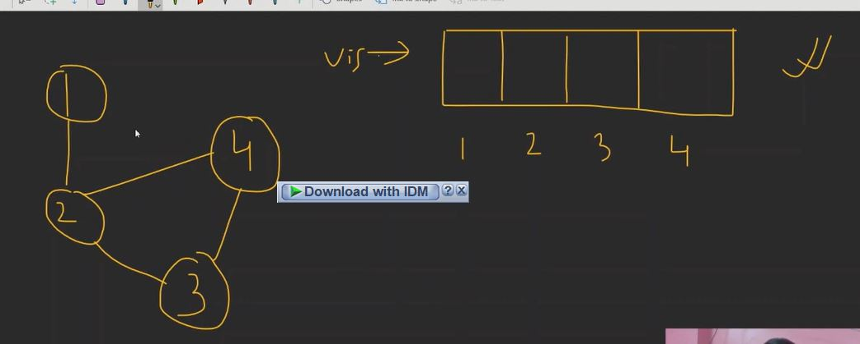

Same as earlier just take vis not order array. Here from 1 to 2 then 3 then 4 then again to 2.this is cycle now how to find it.

Here issue is from 2 it can go to 1 or3 or 4. main issue is it goes back to 1. now how to solve it. here 1 can be seen that it is already visited. We can say it is cycle and hence this is issue report back to parent. We just need to check not equal to parent. If parent just skip it.